The full title of your paper

First name Last name¹, First name Last name²*

¹Department of Civil Engineering, Faculty of Civil Engineering, Polytechnic University of Tirana, St.Muhamet Gjollesha, 54, 1023, Tirana, Albania
²Faculty of Civil Engineering, University of Prishtina, Prishtina, Kosova
* Corresponding author: email;

Abstract

The abstract section should be in 12-point normal Times New Roman. (maximum 300 words)

Keywords: This section should be written in italic and include a maximum of 6 keywords related with the study.

INTRODUCTION
Please use this template to prepare your article in English (American). SI-units shall be used and acronyms should be written out at their first appearance.
The paper length, including figures, tables and references should not exceed 8 pages.
All text paragraphs should be single spaced, with first line intended by 10 mm

materials and methods

Subheading
The heading levels should not be more than 4 levels. The font of heading and subheadings should be 12-point normal Times New Roman. The first letter of headings and subheadings should be capitalized.

Sub-subheading
Equations should be clear and expressions used should be explained in the text. The equations should be numbered consecutively at the outer right margin, as shown below:

[add an equation here; use MS Word or MathType equation function] (1)

results and discussion
Tables and figures should be placed close after their first reference in the text. All figures and tables should be numbered with Arabic numerals. Table captions should be centered above the tables. Figure captions should be centered below the figures. An example is shown in Table 1 and Figure 1.
Table 1. Caption of the table
 | A | B | C
X | 0,600 | 0,950 | 0,632
Y | 0,529 | 0,881 | 0,600
Z | 0,565 | 0,932 | 0,607
(Table body should be created by MS word table function; three-line table is preferred.)

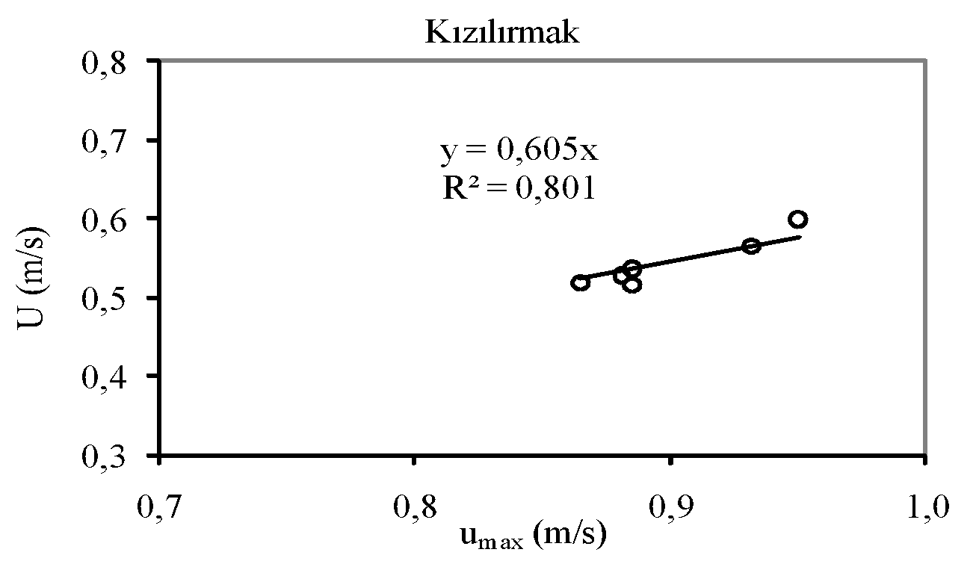
Figure 1. Legend of the figure

conclusion

REFERENCES

Reference numbers in the text should be designated by square brackets, e.g., [1-3]. The references should be listed in the same order as cited in the text. See examples below:

- Vlachopoulos N., Diederichs M. S. (2009) Improved longitudinal displacement profiles for convergence confinement analysis of deep tunnels. Rock Mech Rock Engng, 42: 131–146.
- Barla M. (2011) Elementi di meccanica e ingegneria delle rocce, Celid, Italy.
- Byrne MD. (2013) How Many Times Should a Stochastic Model Be Run? An Approach Based on Confidence Intervals. 12th International Conference on Cognitive Modelling, Canada, 445-450.

SUBMITTING THE PAPER
The manuscript can be submitted electronically after the Abstract Acceptance Notification and on or before June 29, 2025, by e-mail to the e-mail address: secretariat.icce2025@uni-pr.edu

